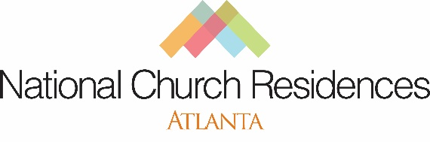

Rise ‘N Shine: A Breakfast To Champion Older Adults
2021 Sponsorship Opportunities

Gold Sponsor — $5,000

• Recognition as a Gold Sponsor in promotions
• Recognition as Gold Sponsor from the virtual stage at Rise ‘N Shine: A Breakfast To Champion Older Adults
• Mentioned in the official virtual event press release
• Opportunity for attendees to see corporate logo during virtual event
• Will receive 10 breakfast care packages shipped directly to sponsor representatives
• Membership in the National Church Residences Cornerstone Society
• Partnership with an innovative and nationally recognized non-profit

Platinum Sponsor — $10,000

• Recognition as a Platinum Sponsor in promotions
• Recognition as Platinum Sponsor from the virtual stage at Rise ‘N Shine: A Breakfast To Champion Older Adults
• Mentioned in the official virtual event press release
• Opportunity to provide remarks and introduce one invited guest speaker
• Opportunity for attendees to see corporate logo during virtual event
• Will receive 10 breakfast care packages shipped directly to sponsor representatives
• Membership in the National Church Residences Cornerstone Society
• Partnership with an innovative and nationally recognized non-profit

Bronze Sponsor — $1,000

• Recognition as a Bronze Sponsor in promotions
• Recognition as Bronze Sponsor from the virtual stage at Rise ‘N Shine: A Breakfast To Champion Older Adults
• Opportunity to see corporate logo during virtual event
• Membership in the National Church Residences Cornerstone Society
• Partnership with an innovative and nationally recognized non-profit
Silver Sponsor — $2,500

• Recognition as a Silver Sponsor in promotions
• Recognition as Silver Sponsor from the virtual stage at Rise ‘N Shine: A Breakfast To Champion Older Adults
• Will receive 10 breakfast care packages shipped directly to sponsor representatives
• Opportunity for attendees to see corporate logo during virtual event
• Membership in the National Church Residences Cornerstone Society
• Partnership with an innovative and nationally recognized non-profit

YES! – I am interested in being a sponsor of Rise ‘N Shine 2021!

Level: (please circle one)
Platinum Gold Silver Bronze

Name:_________________________________________________________________________________________________________________
Company/Organization Name:______________________________________________________________________________________________
Address:________________________________________________________________City_________________________ST_____Zip_________
Phone:__________________________________Email:_________________________________________________________________________

For more information on sponsorships, contact Sojourner Marable Grimmett,
Senior Director of External Affairs & Strategic Partnerships, Atlanta Region at (404) 783-3522.

