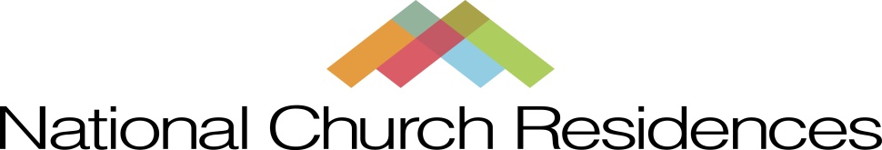

Questions & Answers

Q: Must we get approval for our virtual event idea and celebration date?
A: Please approach Mission Day activities just like you would for any other approval needed as set forth by leadership.

Q: We have an approved virtual event idea and a date for our Mission Day celebration, now what?
A: Register your event and provide all the known details via the link provided on the Mission Day Landing Page.

Q: Where do we get the resources, (funds, signage, food, entertainment etc.) to host our virtual Mission Day event?
A: You are encouraged to be creative! Seeking sponsorships & partnerships from within your community is ideal. Funds spent from your budget are totally unique to each property. Discuss funding and resources needed with your Property/Regional Manager and/or your Administrator before making any decisions.

Q: Is Crowd Funding mandatory?
A: No, but it is an additional avenue to raise funds and generate interest from your friends, family and Social Media network.

Q: Will the funds raised by me or any other person associated with my property via Crowd Funding or any other source benefit my property?
A: Yes, as long as the Foundation can identify the property that is associated with the funds received and that no other directive has been given to where the funds should be applied.

Q: So we held our virtual event, now what?
A: Provide a final summary of your 2020 Mission Day virtual event by clicking on the “Final Summary” link found on the Mission Day Landing Page. Make sure to provide as much detail as possible. Please provide photos and/or video of your event (please make sure you have photo releases for photos of residents). We want to celebrate your efforts and those you serve by capturing the memories of your virtual 2020 Mission Day event.

Q: We raised some money, now what?
A: Please follow the procedures in the Foundation Funds Transfer Policy on Cornerstone
http://cornerstone.ncr.org/Corporate/NCR%20Foundation/Forms/AllItems.aspx?RootFolder=%2FCorporate%2FNCR%20Foundation%2FPhilanthropy%20Tool%20Kit&FolderCTID=0x0120006C49769C574D3D478C0276BA5B58FD5C&View={15173F53-9EAA-417D-A354-23E8D160DC9B}
- Mail your monies to National Church Residences Foundation at 2335 North Bank Drive Columbus, Ohio 43220.
- Please indicate that the funds represent Mission Day 2020.
- Provide appropriate documentation for the type of gift received, i.e., cash or product.
- Provide property name, purpose of the gift, donor information, and date of gift.
- If an in-kind gift is received, report it to Foundations with explanation for the gift.
- Do not send a personal check for cash received, please get a money order or cashier’s check.
- The Foundation will acknowledge all gifts for tax acknowledgement purposes.
Q: When it comes time to spend our Mission Day money – what is the procedure for getting our funds?
A: The process is easy – contact Kendra Rayl for more information or refer to the Foundation Funds Transfer Policy on Cornerstone.

Q: We have questions, need some guidance, who do we contact?
A: Kendra Rayl is your primary contact for Mission Day. She can be reached at 614.273.3585, or via email at krayl@nationalchurchresidences.org.

